Teacher: | Sharon Pullen ELA 6th grade
Date: | 11/13/17
Standards: | RL6.1: Cite textual evidence to support analysis of text, both inferential and explicit.  RL 6.2: Determine theme/central idea of text and how it is conveyed through particular details.  RL 6.10:By end of year, read and comprehend literature in 6-8 text complexity band proficiently (stories, poems, drama).  RI6.4: Determine the meaning of words and phrases as they are used in text.  L 6.5: Interpret figures of speech in context.
I Can… | I can go back to the text and cite evidence to support claims  I can read text and determine the message the author wants the reader to understand  I can write develop a response to a writing prompt with good organization appropriate to the audience.  I can write routinely to develop stamina for any writing purpose
DOK Level:1 | Snow Treasure reading
DOK Level:2 | List character traits of main character  Identify Norway on a map  Continue plot diagram
DOK Level:3 | cite evidence and develop a logical argument for conjectures  apply compare and contrast idea to character traits from book
DOK Level:4 | Develop informative writing project
Resources: | CSET poster  i-ready  Task Cards  Second term voc. list  DOK Chart  Student individual reading Q&A  Quizlet  https://www.youtube.com/watch?v=1_DA6zAtvp0  https://www.visitnorway.com/about/  https://www.scholastic.com/content/collateral_resources/pdf00premium/8X/043957238X_e.pdf

Monday –
DGP - The dog jumped.
Snow Treasure
Task Cards / independent student reading
Informational writing instruction (Performance Assessment)
Tuesday -
DGP The dog jumped.
Snow Treasure review
Task Cards / independent student reading
Informational writing instruction (Performance Assessment)
Wednesday –
DGP –The dog jumped.
Snow Treasure
Snow Treasure quiz
Informational writing instruction (Performance Assessment)
Thursday -
DGP - The dog jumped.
Snow Treasure
i-ready
Informational writing instruction (Performance Assessment)
Friday -
DGP - The dog jumped.
i-ready
Informational writing instruction (Performance Assessment)

Vocabulary

Literary Terms Set #2
informative | A type or writing that provides useful or interesting information
expository/explanatory | A type of writing that explains or describes something
annotation | A note to explain or comment on a text
topic | A subject discussed in a text
main idea/central idea | A statement(s) that tells the most important thoughts about a topic. It is supported by details.
graphics | The use of diagrams or visual images
citation | A quote from a text
transition word | A word that smoothly connects two topics in writing
text structure/format | The organizational pattern of a text
text features | Features that help organize the text, such as: headings, lists, sidebars,  and graphic aids

Snow Treasure Quiz #1
Use any notes from your book or notebook to answer the questions below.
1. Snow Treasure’s setting was…
a. ____________________________

b. ____________________________

c. ____________________________

2. The protagonist of Snow Treasure was __________________________.

3. On the map color Norway green.
4. On the map color Germany red.
5. On the picture color a fiord blue.

6. The overall conflict was between
a. Germany and Norway
b. Norway and Switzerland
c. Germany and England

7. Who did the gold bricks belong to?
a. Germany
b. Norway
c. England

8. Why were the Norwegian people afraid of rain?

9. Why were the Norwegian children in danger?

10. List one character trait of Peter__________________________ and one from Helga______________________________.

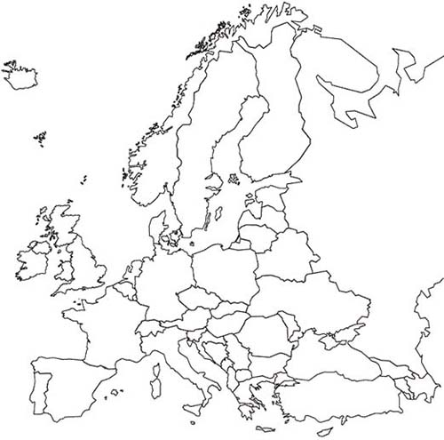
Color Norway green
Color the fiord blue
Color Germany red
