Teacher: | Sharon Pullen | Subject | ELA
Date: | 9/5/17 | Grade: | 7th
Standards: | RL 7.1: Cite textual evidence to support analysis of text, both inferential and explicit.  RL 7.2: Determine theme/central idea of text and analyze its development throughout text.  RL 7.7: Compare/Analyze reading experience with viewing video, live performance, movie.  W 7.4: Produce clear and coherent writing in which the development, organization, and style are appropriate to task, purpose, and audience.  W 7.5: Develop and strengthen writing by planning, revising, editing, rewriting, or trying a new approach.  W 7.10: Write routinely for shorter time frames (a single sitting or a day or two) for a range of discipline specific  tasks, purposes, and audiences.  RL 7.10: By end of year, read and comprehend literature in 6-8 text complexity band proficiently (stories, poems, drama). | Connects with
I Can… | I can go back to the text and cite evidence to support claims  I can read text and determine the message the author wants the reader to understand  I can develop a response to a writing prompt with good organization appropriate to the audience.  I can write routinely to develop stamina for any writing purpose
DOK Level: 1

DOK Level: 2 | Use context clues to interpret nautical terms or phrases
DOK Level: 3 | Cite evidence from the three news articles in support of decision of acceptable age to sail around the world.
DOK Level: 4 | Students use their understanding of the three sources to develop an opinion of whether Abby’s age was a factor in the circumstances’ that lead to her failure to sail around the world. The students will try and synthesize the sources and use text evidence in support of their opinion.
Summarizing Activities:
Resources: | CSET poster  http://my.hrw.com  Flocabulary https://www.flocabulary.com/unit/fact-and-opinion/video/

Monday –
Daily Grammar Practice warm-up (capitalization and punctuation)
the funny magician showed my friends and me several neat tricks

Centers:
Reading: Readworks article
Writing: Writing Prompt use CSET What is your favorite holiday? Why?

Whole Group:
- Review vocabulary
- Students will develop an opinion statement relating their own opinion to the question of Abby Sounderland’s attempt to sail around the world solo.
- Georgia Collections writing prompt – instruction on finding textual evidence, and using it in the response to the prompt.

Tuesday –
Daily Grammar Practice warm-up Identify Identify parts of speech including noun (noun), pronoun (type, case, person), verb (type and tense), adverb, adjective, article, preposition, conjunction (type)
the funny magician showed my friends and me several neat tricks
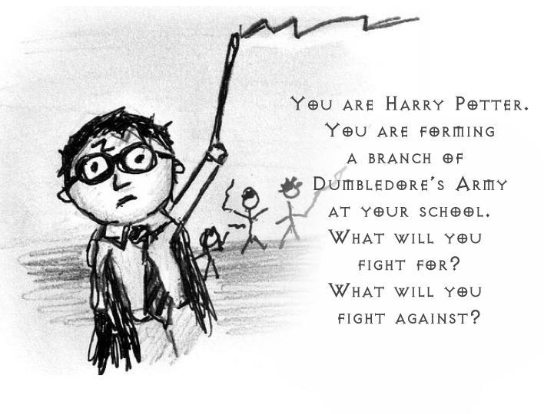
Centers:
Reading: Readworks article
Writing: Writing Prompt use CSET

Whole Group:
- Review vocabulary
- Students will develop an opinion statement relating their own opinion to the question of Abby Sounderland’s attempt to sail around the world solo.
- Georgia Collections writing prompt – instruction on finding textual evidence, and using it in the response to the prompt.
Homework check

Wednesday - Daily Grammar Practice warm-up Identify sentence parts including simple and complete subject, simple and complete predicate, (transitive or intransitive verb), direct object
the funny magician showed my friends and me several neat tricks
Centers:
Reading: Readworks article
Writing: Writing Prompt use CSET

Whole Group:
- Review vocabulary
- Students will develop an opinion statement relating their own opinion to the question of Abby Sounderland’s attempt to sail around the world solo.
- Georgia Collections writing prompt – instruction on finding textual evidence, and using it in the response to the prompt.

Thursday - Daily Grammar Practice warm-up Identify clauses (independent, adverb dependent, adjective dependent), sentence type (simple, compound, complex, compound-complex), and purpose (declarative, imperative, interrogative, exclamatory).
the funny magician showed my friends and me several neat tricks
Centers:
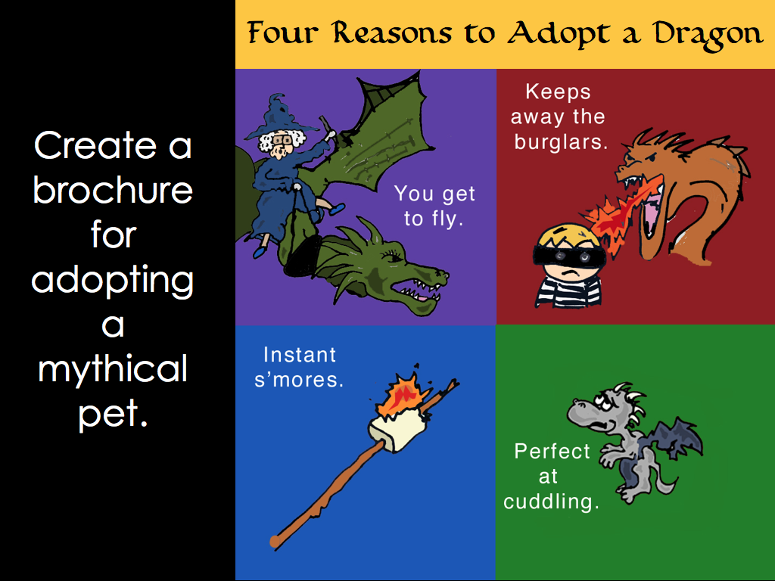
Reading: Readworks article
Writing: Writing Prompt use CSET

Whole Group:
- Review vocabulary
- Students will develop an opinion statement relating their own opinion to the question of Abby Sounderland’s attempt to sail around the world solo.
- Georgia Collections writing prompt – instruction on finding textual evidence, and using it in the response to the prompt.

Homework check

Friday - Daily Grammar Practice warm-up sentence diagraming for Friday
the funny magician showed my friends and me several neat tricks
Centers:
Reading: Readworks article
Writing: Writing Prompt use CSET How would you like to help in our community? Why?
Whole Group:
- Review vocabulary
- Students will develop an opinion statement relating their own opinion to the question of Abby Sounderland’s attempt to sail around the world solo.
- Georgia Collections writing prompt – instruction on finding textual evidence, and using it in the response to the prompt.

Vocabulary-
Plot, Exposition, Setting, Characters, Rising action, Climax, Falling Action, Resolution, Conflict, External Conflict, Internal Conflict, CSET – Claim, Set-up, Evidence, Tie-in

