Teacher | Sharon Pullen ELA 7th Grade
Date: | 12/11/17
I Can… | I can go back to the text and cite evidence to support claims  I can read text and determine the message the author wants the reader to understand  I can read and determine  I can write and develop a response to a writing prompt with good organization appropriate to the audience.  I can write routinely to develop stamina for any writing purpose
DOK Level: 1 | Read The cay
DOK Level: 2 | Discuss The Cay’s plot diagram rising action  Draw a time line of The Cay and list major events occurring in chronological order.
DOK Level: 3 | Cite evidence and develop a logical argument for concepts or solutions  Create more detailed sentences from a three word beginning sentence
DOK Level: 4 | Constructed response practice
Resources: | The Cay  CSET poster  i-ready  DOK Chart  Plot Diagram
Monday –
Bellringer - pronouns
DGP - Correcting sentence fragments & run ons
The Cay today read more of the book
Continue drawing a time line of The Cay and list major events occurring in chronological order.
Whole – introduction to pronouns
Independent Work - Continue drawing a time line of The Cay and list major events occurring in chronological order.
Tuesday –
Bellringer - pronouns
DGP Correcting sentence fragments & run ons
Whole Group - pronouns
Independent Work - Continue drawing a time line of The Cay and list major events occurring in chronological order.

Wednesday -
Bellringer - pronouns
DGP – Correcting sentence fragments & run ons
Whole Group – pronouns
Independent Work - Continue drawing a time line of The Cay and list major events occurring in chronological order.
Thursday –
Bellringer - pronouns
DGP
Whole group - pronouns
i-ready
Friday –
Bellringer - pronouns
i-ready
What is a pronoun?
In grammar, a pronoun is defined as a word or phrase that may be substituted for a noun or noun phrase, which once replaced, is known as the pronoun’s antecedent. How is this possible? In a nutshell, it’s because pronouns can do everything that nouns can do.

Types of Pronouns
Pronouns can be divided into numerous categories including:
- Indefinite pronouns – those referring to one or more unspecified objects, beings, or places
- Personal pronouns – those associated with a certain person, thing, or group; all except you have distinct forms that indicate singular or plural number
- Reflexive pronouns – those preceded by the adverb, adjective, pronoun, or noun to which they refer, and ending in –self or –selves
- Demonstrative pronouns – those used to point to something specific within a sentence
- Possessive pronouns – those designating possession or ownership
- Relative pronouns – those which refer to nouns mentioned previously, acting to introduce an adjective (relative) clause
- Interrogative pronouns – those which introduce a question
- Reciprocal pronouns – those expressing mutual actions or relationship; i.e. one another
- Intensive pronouns – those ending in –self or –selves and that serve to emphasize their antecedents

Examples of Pronouns
In the following examples, the pronouns are italicized.
- We are going on vacation.
- Don’t tell me that you can’t go with us.
- Anybody who says it won’t be fun has no clue what they are talking about.
- These are terribly steep stairs.
- We ran into each other at the mall.
- I’m not sure which is worse: rain or snow.
- It is one of the nicest Italian restaurants in town.
- Richard stared at himself in the mirror.
- The laundry isn’t going to do itself.
- Someone spilled orange juice all over the countertop!

PRONOUNS

Pronouns are words that substitute for nouns.

Every pronoun must have a clear antecedent (the word for which the pronoun stands).
KINDS OF PRONOUNS
A. Personal Pronouns:

SINGULAR |  |  |  | PLURAL
 | subjective | objective | possessive | subjective | objective | possessive
1st person | I | me | my, mine | we | us | our, ours
2nd person | you | you | your, yours | you | you | your, yours
3rd person | he  she  it | him  her  it | his  her, hers  its | they | them | their, theirs

Personal pronouns have the following characteristics:
1. three persons (points of view
1st person - the one(s) speaking (I me my mine we us our ours)
2nd person - the one(s) spoken to (you your yours)
3rd person - the one(s) spoken about (he him his she her hers it its they their theirs)
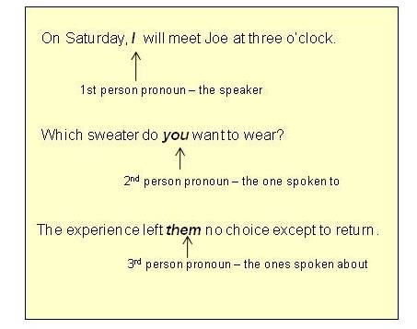
2. three genders
feminine (she her hers)
masculine (he him his)
neuter (it its they them their theirs)
Examples
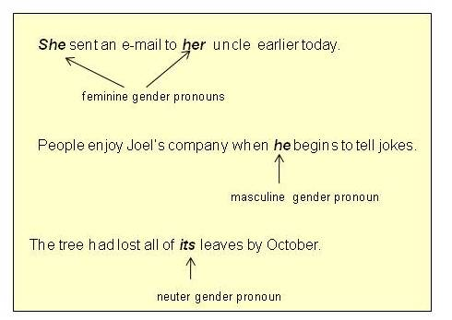
3. two numbers
singular (I me my mine you your yours he him his she her hers it its)
plural (we us our ours you your yours they them their theirs)
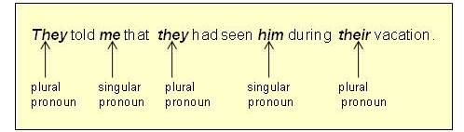
4. three cases
subjective (I you he she it we they)
possessive (my mine your yours his her hers our ours their theirs)
objective (me you him her it us them)
Examples - subjective case
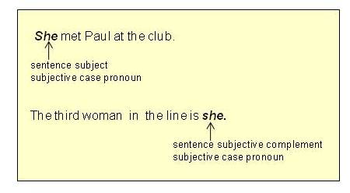
Examples - possessive case
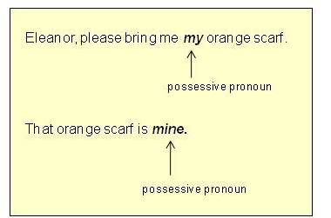
Examples - objective case
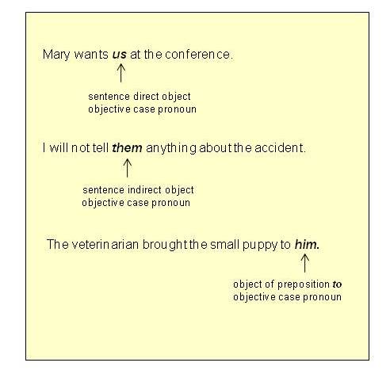 NOTE: Because of pronoun case, the pronoun's form changes with its function in the sentence. Follow this link to pronoun case for more information.
B. Demonstrative Pronouns:

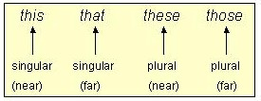

Demonstrative pronouns can also be used as determiners.
Example:
Hand me that hammer. (that describes the noun hammer)

Demonstrative pronouns can also be used as qualifiers:
Example:
She wanted that much money? (that describes the adjective much)

C. Reflexive / Intensive Pronouns : the "self" pronouns

These pronouns can be used only to reflect or intensify a word already there in the sentence.

Reflexive / intensive pronouns CANNOT REPLACE personal pronouns.

Examples:
I saw myself in the mirror. (Myself is a reflexive pronoun, reflecting the pronoun I.)
I’ll do it myself. (Myself is an intensive pronoun, intensifying the pronoun I.)
Note: The following words are substandard and should not be used:

theirselves theirself hisself ourself

D. Indefinite Pronouns:
Singular:

one | someone | anyone | no one | everyone
each | somebody | anybody | nobody | everybody
(n)either | something | anything | nothing | everything

Examples:
Somebody is coming to dinner.
Neither of us believes a word Harry says.
Plural:
Examples:
Both are expected at the airport at the same time.
Several have suggested canceling the meeting.
Singular with non-countables / Plural with countables:
Examples:
Some of the dirt has become a permanent part of the rug.
Some of the trees have been weakened by the storm.
Indefinite pronouns use apostrophes to indicate possessive case.
Examples:
The accident is nobody’s fault.
How will the roadwork affect one's daily commute?
Some indefinite pronouns may also be used as determiners.
one, each, either, neither, some, any, one, all, both, few, several, many, most
Note the differences:
Each person has a chance.
(Each is a determiner describing person.)
Each has a chance.
(Each is an indefinite pronoun replacing a noun.)
Both lawyers pled their cases well.
(Both is a determiner describing lawyers.)
Both were in the room.
(Both is an indefinite pronoun replacing a noun.)
E. Interrogative Pronouns:
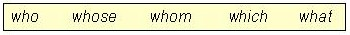
Interrogative pronouns produce information questions that require more than a “yes” or “no” answer.
Examples:
What do you want?
Who is there?
F. Relative Pronouns:
Relative pronouns introduce relative (adjectival) clauses.
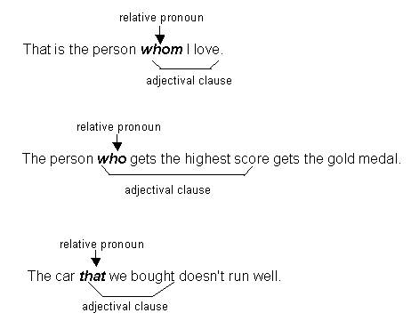

Note: | Use who, whom, and whose to refer to people.
 | Use that and which to refer to things.

Name: ____________________________________________ Fragments & Sentences
If the group of words is a complete sentence, write the letter S on the line. If the group of words is a fragment, write an F on the line.
_______ 1. Yesterday when I got off the school bus.
_______ 2. My friend Sheila and I saw a brown toad hopping on the sidewalk.
_______ 3. Yelled and screamed when she saw it.
_______ 4. My friend Sheila, who is scared of all reptiles.
_______ 5. I picked up the toad and looked closely at it.
_______ 6. Had dry, bumpy skin on its body.
_______ 7. Shelia said, “I don't want to see that ugly toad!”
_______ 8. Said, “Then close your eyes Sheila.”
_______ 9. Sheila was mad and she ran off.
_______ 10. I put the toad in my backpack.
_______ 11. Took it home to show my brother.
_______ 12. My brother wasn't home from school ye
t. _______ 13. Then I put the backpack on the living room sofa.
_______ 14. The toad was still inside.
_______ 15. My mother opened the backpack to see what homework I had.
_______ 16. Hopped out of the backpack and began jumping around the living room floor.
_______ 17. Screamed loudly!
_______ 18. Do you think my mother will let me keep the little brown toad? Super Teacher Worksheets –

www.superteacherworksheets.com
ANSWER KEY Fragments & Sentences If the group of words is a complete sentence, write the letter S on the line. If the group of words is a fragment, write an F on the line.
F 1. Yesterday when I got off the school bus.
S 2. My friend Sheila and I saw a brown toad hopping on the sidewalk.
F 3. Yelled and screamed when she saw it.
F 4. My friend Sheila, who is scared of all reptiles.
S 5. I picked up the toad and looked closely at it.
F 6. Had dry, bumpy skin on its body.
S 7. Shelia said, “I don't want to see that ugly toad!”
F 8. Said, “Then close your eyes Sheila.”
S 9. Sheila was mad and she ran off.
S 10. I put the toad in my backpack.
F 11. Took it home to show my brother.
S 12. My brother wasn't home from school yet.
S 13. Then I put the backpack on the living room sofa.
S 14. The toad was still inside.
S 15. My mother opened the backpack to see what homework I had.
F 16. Hopped out of the backpack and began jumping around the living room floor.
F 17. Screamed loudly!
S 18. Do you think my mother will let me keep the little brown toad?

