Teacher | Sharon Pullen ELA 7th Grade
Date: | 11-6-17
Standards: | RL 7.1: Cite textual evidence to support analysis of text, both inferential and explicit.  RL 7.2: Determine theme/central idea of text and analyze its development throughout text.  W 7.4: Produce clear and coherent writing in which the development, organization, and style are appropriate to task, purpose, and audience.  W 7.5: Develop and strengthen writing by planning, revising, editing, rewriting, or trying a new approach.  W 7.10: Write routinely for shorter time frames (a single sitting or a day or two) for a range of discipline specific tasks, purposes, and audiences.  RL 7.10: By end of year, read and comprehend literature in 6-8 text complexity band proficiently (stories, poems, drama).
I Can… | I can go back to the text and cite evidence to support claims  I can read text and determine the message the author wants the reader to understand  I can read and determine  I can write and develop a response to a writing prompt with good organization appropriate to the audience.  I can write routinely to develop stamina for any writing purpose
DOK Level: 1 | Read The cay
DOK Level: 2 | Cite evidence showing 1st person point of view
DOK Level: 3 | Cite evidence and develop a logical argument for concepts or solutions  Cite evidence and develop a logical argument for concepts or solutions
DOK Level: 4
Resources: | The Cay  CSET poster  Task cards  i-ready  DOK Chart  Individual reading Q&A  Quizlet  Plot Diagram  Point of view definition  https://docs.google.com/presentation/d/1XKSJ91yQFmcVtHNig8mcMiAGM74X937O5Rw5L3p6VsQ/edit?ts=59f1e734&pli=1#slide=id.p74  https://poway.instructure.com/courses/10735/pages/the-cay-audio-files  https://quizlet.com/105309755/plot-events-in-the-cay-flash-cards/

Monday –
DGP - Landon ran.
The Cay
Introduce point of view in writing https://www.youtube.com/watch?v=1_DA6zAtvp0
Task Cards / independent student reading
i-ready
Informational writing instruction (Performance Assessment)
Tuesday –
DGP – Landon ran.
Review of point of view
The Cay plot diagram https://quizlet.com/105309755/plot-events-in-the-cay-flash-cards/
Task Cards / independent reading
i-ready
Informational writing instruction (Performance Assessment)
Wednesday -
DGP - Landon ran.
The Cay
Task Cards / independent reading
i-ready
Informational writing instruction (Performance Assessment)
Thursday –
DGP - Landon ran.
Task Cards /independent student reading
i-ready
Informational writing instruction (Performance Assessment)
Friday –
DGP - Landon ran.
Make up day
Task Cards – independent student reading
i-ready
Informational writing instruction (Performance Assessment)

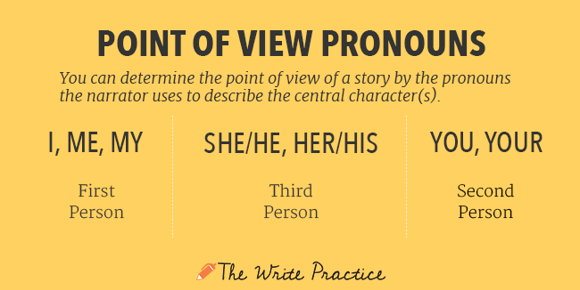

Who is the narrator, can she or he read minds, and, more importantly, can we trust her or him?
In first person point of view, the narrator is in the story and relating the events he or she is personally experiencing. First person narrators cannot be everywhere at once and thus cannot get all sides of the story. They are telling their story, not necessarily the story.
The Cay is told retrospectively from our protagonist Phillip's point of view. The narrative is written in the first person, which means that Phillip is telling the story himself. He's a "central" narrator because he's telling the story about himself – he's the star in his own story. We get lots of insight into what the young Phillip is thinking and feeling, which allows us to see more clearly the personal transformation he undergoes.
On the downside, we don't really get to see what other characters, like Timothy, are thinking; we are dependent upon Phillip for all of the information we get. While the first-person perspective gives us a rich view of Phillip's inner life, we are left wondering about other characters' points of view.
Second person point of view isn’t used frequently in novels.
In third person, the narrator is outside of the story and relating the experiences of a character. The central character is not the narrator. In fact, the narrator is not present in the story at all.
In Third person omniscient the narrator has full access to all the thoughts and experiences of all the characters in the story.
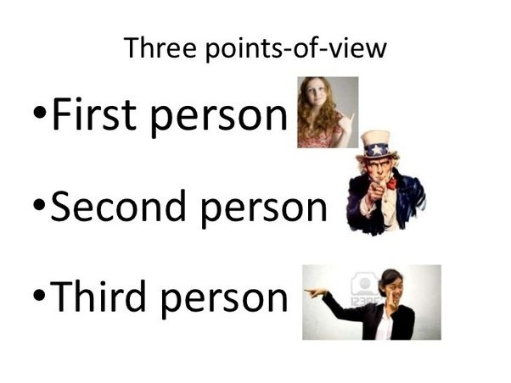
https://www.youtube.com/watch?v=1_DA6zAtvp0

Norway is a Scandinavian country encompassing mountains, glaciers and deep coastal fjords. Oslo, the capital, is a city of green spaces and museums. Preserved 9th-century Viking ships are displayed at Oslo’s Viking Ship Museum. Bergen, with colorful wooden houses, is the starting point for cruises to the dramatic Sognefjord. Norway is also known for fishing, hiking and skiing, notably at Lillehammer’s Olympic resort.

https://www.visitnorway.com/about/

