Teacher: | Sharon Pullen ELA 6th grade
Date: | 11/6/17
Standards: | RL6.1: Cite textual evidence to support analysis of text, both inferential and explicit.  RL 6.2: Determine theme/central idea of text and how it is conveyed through particular details.  RL 6.10:By end of year, read and comprehend literature in 6-8 text complexity band proficiently (stories, poems, drama).  RI6.4: Determine the meaning of words and phrases as they are used in text.  L 6.5: Interpret figures of speech in context.
I Can… | I can go back to the text and cite evidence to support claims  I can read text and determine the message the author wants the reader to understand  I can write develop a response to a writing prompt with good organization appropriate to the audience.  I can write routinely to develop stamina for any writing purpose
DOK Level:1 | Snow Treasure reading
DOK Level:2
DOK Level:3 | cite evidence and develop a logical argument for conjectures  apply compare and contrast idea to character traits from book
DOK Level:4 | Begin to develop informative writing project
Resources: | CSET poster  i-ready  Task Cards  Second term voc. list  DOK Chart  Student individual reading Q&A  Quizlet  https://www.youtube.com/watch?v=1_DA6zAtvp0  https://www.visitnorway.com/about/  https://www.scholastic.com/content/collateral_resources/pdf00premium/8X/043957238X_e.pdf

Monday –
DGP - Connor ran.
Begin with prior knowledge
Snow Treasure
Introduce point of view in writing
https://www.youtube.com/watch?v=1_DA6zAtvp0
Task Cards / independent student reading
i-ready
Informational writing instruction (Performance Assessment)
Tuesday -
DGP - Connor ran.
Continue with prior knowledge
Snow Treasure
Point of view review
Task Cards / independent student reading
i-ready
Informational writing instruction (Performance Assessment)
Wednesday –
DGP – DGP - Connor ran.
Snow Treasure
Plot diagram work
Task Cards / independent student reading
i-ready
Informational writing instruction (Performance Assessment)
Friday –
DGP - Connor ran.
Snow Treasure
Plot diagram
Character Traits organizer
Task Cards / independent student reading
i-ready
Informational writing instruction (Performance Assessment)

Vocabulary

Literary Terms Set #2
informative | A type or writing that provides useful or interesting information
expository/explanatory | A type of writing that explains or describes something
annotation | A note to explain or comment on a text
topic | A subject discussed in a text
main idea/central idea | A statement(s) that tells the most important thoughts about a topic. It is supported by details.
graphics | The use of diagrams or visual images
citation | A quote from a text
transition word | A word that smoothly connects two topics in writing
text structure/format | The organizational pattern of a text
text features | Features that help organize the text, such as: headings, lists, sidebars,  and graphic aids
domain-specific vocabulary | Content-specific words that are not used in general in conversation
supporting evidence | Relevant quotations and concrete details that support the main idea

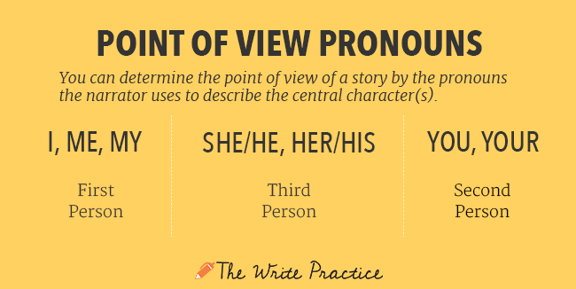

Who is the narrator, can she or he read minds, and, more importantly, can we trust her or him?
In first person point of view, the narrator is in the story and relating the events he or she is personally experiencing. First person narrators cannot be everywhere at once and thus cannot get all sides of the story. They are telling their story, not necessarily the story.
The Cay is told retrospectively from our protagonist Phillip's point of view. The narrative is written in the first person, which means that Phillip is telling the story himself. He's a "central" narrator because he's telling the story about himself – he's the star in his own story. We get lots of insight into what the young Phillip is thinking and feeling, which allows us to see more clearly the personal transformation he undergoes.
On the downside, we don't really get to see what other characters, like Timothy, are thinking; we are dependent upon Phillip for all of the information we get. While the first-person perspective gives us a rich view of Phillip's inner life, we are left wondering about other characters' points of view.
Second person point of view isn’t used frequently in novels.
In third person, the narrator is outside of the story and relating the experiences of a character. The central character is not the narrator. In fact, the narrator is not present in the story at all.
In Third person omniscient the narrator has full access to all the thoughts and experiences of all the characters in the story.
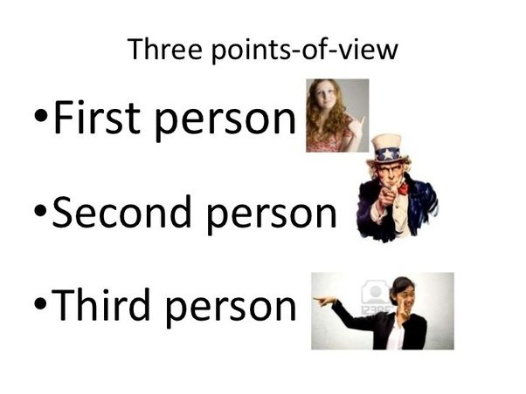
https://www.youtube.com/watch?v=1_DA6zAtvp0

