Teacher: | Sharon Pullen | Subject | ELA
Date: | 10/2/17 | Grade: | 6th
Standards: | RL6.1: Cite textual evidence to support analysis of text, both inferential and explicit.  RL 6.2: Determine theme/central idea of text and how it is conveyed through particular details.  RL 6.10:By end of year, read and comprehend literature in 6-8 text complexity band proficiently (stories, poems, drama).  RI6.4: Determine the meaning of words and phrases as they are used in text.  L 6.4:Use context as a clue to the meaning of a word or phrase.  L 6.4:Consult dictionaries/glossaries/thesauruses to identify or verify word meanings.  L 6.5: Interpret figures of speech in context.  W6.4: Produce clear and coherent writing in which the development, organization, and style are appropriate to task, purpose, and audience.  W 6.10:Write routinely for shorter time frames (a single sitting or a day or two) for a range of discipline-specific tasks, purposes, and audiences. | Connects with
I Can… | I can go back to the text and cite evidence to support claims  I can read text and determine the message the author wants the reader to understand  I can write develop a response to a writing prompt with good organization appropriate to the audience.  I can write routinely to develop stamina for any writing purpose  I can read and understand figurative writing
DOK Level:1 | Vocabulary: Review terms  Simile, Metaphor, Personification, Alliteration, Onomatopoeia, Hyperbole, Symbolism, Plot, Exposition, Setting, Characters, Rising action, Climax, Falling Action, Resolution, Conflict, External Conflict, Internal Conflict, CSET – Claim, Set-up, Evidence, Tie-in  Vocabulary: from Zane and the Hurricane (Quizlet)
DOK Level:2
DOK Level:3 | Time line sequencing of Zane and the Hurricane
DOK Level:4 | Work on Choice Board  Continue working on a time line showing when specific events occurred in the story showing their relationship to other events in the story.
Resources: | plot diagram organizer  CSET poster  https://jr.brainpop.com/readingandwriting/writing/writingaparagraph/
Monday - Review noun, verb, helping verb, article adjective, and direct object
1. Divide the class into 2 groups Group 1 Lauren, John, Connor Group 2 JoJo, Tucker
2. Tell the students that they will compete to see who wins this warm up activity and
their prize will be ice cream when I get back to school.
3. The boy was flying the kite.
4. Give the students 10 minutes to work in their group and label each word in the
sentence
Students need their Chromebooks for activities
Google Classroom (quizlet)30 min.
Google classroom – Have the students make flash cards from the vocabulary that can be
found from the quizlet websites in Google Classroom under my
name (Pullen). Index Cards can be found in my desk. The flash
cards need to show the vocabulary term on one side and the
definition on the other side of the card. They can color and decorate
the cards but they must be able to read what is written on them.
Choice Board 30 min.
Writing – Novel Study Choice Board
Read the selections from the choice board aloud. Students need to complete at least 4
activities from the list; they can choose which. I do not expect student to
complete these activities on the first day; however I do expect them to work on them
Monday through Wednesday. If they fly through this assignment and do a poor job they will re-do the assignment. This is individual work not group or partner work.
Have students use the book ZANE AND THE HURRICANE for a reference to help them answer these activities. They may need for you to read parts of the book to help them do the activities.
Tuesday - Google Classroom (quizlet)30 min.
Google classroom – Have the students make flash cards from the vocabulary that can be
found from the quizlet websites in Google Classroom under my
name (Pullen). Index Cards can be found in my desk. The flash
cards need to show the vocabulary term on one side and the
definition on the other side of the card. They can color and decorate
the cards but they must be able to read what is written on them.
Choice Board 30 min.
Writing – Novel Study Choice Board
Read the selections from the choice board aloud. Students need to complete at least 4
activities from the list; they can choose which. I do not expect student to
complete these activities on the first day; however I do expect them to work on them
Monday through Wednesday. If they fly through this assignment and do a poor job they will re-do the assignment. This is individual work not group or partner work.
Have students use the book ZANE AND THE HURRICANE for a reference to help them answer these activities. They may need for you to read parts of the book to help them do the activities.
Wednesday – Google Classroom (quizlet)30 min.
Google classroom – Have the students make flash cards from the vocabulary that can be
found from the quizlet websites in Google Classroom under my
name (Pullen). Index Cards can be found in my desk. The flash
cards need to show the vocabulary term on one side and the
definition on the other side of the card. They can color and decorate
the cards but they must be able to read what is written on them.
If students finish with the flash cards they can pair off and practice the terms

Choice Board 30 min.
Writing – Novel Study Choice Board
Read the selections from the choice board aloud. Students need to complete at least 4
activities from the list; they can choose which. I do not expect student to
complete these activities on the first day; however I do expect them to work on them
Monday through Wednesday. If they fly through this assignment and do a poor job they will re-do the assignment. This is individual work not group or partner work.
Have students use the book ZANE AND THE HURRICANE for a reference to help them answer these activities. They may need for you to read parts of the book to help them do the activities.
Thursday - Daily Grammar Practice warm-up short noun, verb, adverb, adjective, preposition

Review terms - Students will find examples of underlined terms in novel Zane and the Hurricane
Simile, Metaphor, Personification, Alliteration, Onomatopoeia, Hyperbole, Symbolism, Plot, Exposition, Setting, Characters, Rising action, Climax, Falling Action, Resolution, Conflict, External Conflict, Internal Conflict, CSET – Claim, Set-up, Evidence, Tie-in

Whole Group: Try to work toward finishing up reading Zane and the Hurricane 20 Min.
Computer: I-Ready 40 min.

Friday – DGP Practice - Prepositional phrase practice

Whole Group: Try to work toward finishing up reading Zane and the Hurricane until completing book
Computer: I-Ready 20min.
Complete and check vocabulary and Choice Board work

Noun - a word that is the name of something (such as a person, animal, place, thing, quality, idea) and is typically used in a sentence as subject or object of a verb or as object of a preposition.
- Person – A term for a person, whether proper name, gender, title, or class, is a noun.
- Animal – A term for an animal, whether proper name, species, gender, or class is a noun.
- Place – A term for a place, whether proper name, physical location, or general locale is a noun.
- Thing – A term for a thing, whether it exists now, will exist, or existed in the past is a noun.
- Idea – A term for an idea, be it a real, workable idea or a fantasy that might never come to fruition is a noun.
Person – John started to run.
Animal – Elephants never forget.
Place – Let’s go to the beach.
Thing – Please close the door and lock it.
Idea – Follow the rules.

Verb - A verb is a word that expresses an action or a state of being. A verb forms the predicate of a sentence.
Physical action
run, jump, dance, write, kick, etc.
In reality, verbs may also refer to an action done mentally such as:
think, ponder, guess, imagine, wonder, etc.
-a linking verb is a kind of verb that links a subject to the complement.
am, is, was, are, were, has been, might have been, become
Both action verbs and linking verbs can accompany helping verbs including the three main ones: do, be, and have.
- to be: am, is, are, was, were, be, being, been.
- to have: have, has, had. to do: do, does, did.
- conditionals: could, should, would, can, shall, will, may, might, must.
Article Adjective – the, a, an
Direct Object - You can find the direct object by finding the verb and asking what? (or whom?). For example:
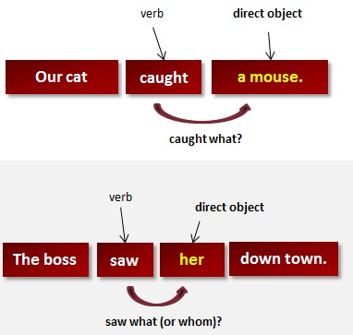

Novel Study Choice Board
Write a poem about two main events in the story. | Draw a picture of the main character, and then write ten words that describe the main character. | Compare one of the main settings of the story to the setting where you live. | Design a comic strip that shows the sequence of events in the story.
Pick five vocabulary words you found interesting. Use them in a different  sentence. | Pick 5 events.  Write cause and effect statements for those events. | Connect with the to the story, including a connection to your life, to another book you have read, and to the real world. | Pick a scene that is  described in detail in the story. Draw a detailed picture and then write your own description of  what is happening.
Write at least 4 predictions about what you think will happen later in the story (or after the end). Why do you think these things will happen? | Create a graphic organizer comparing and contrasting two characters in the  story. | Draw a picture that illustrates the main setting in the story. | Write two sentences that describe the settings.
Write an interview for a  main character of the book. | Ask at least 5 questions and write the answers to the questions, as the character would respond. | Choose a character and imagine you walked into his room. What would you find  in his room, and why? | Suggest a solution to one of the problems from  the text.

1. What is the name of the hurricane in "Zane and the Hurricane"? Katrina
2. Who wrote "Zane and the Hurricane"? Philbrick
3. Where is "Zane and the Hurricane" set? New Orleans
4. Where is Zane visiting from? New Hampshire
5. What is the name of Zane's dog? Bandy
6. What is Bandy short for? Bandit
7. What did Zane call New Orleans? smellyville
8. Who is Zane's great-grandmother? Miss Trissy
9. What does Miss Trissy mention when she wants to change the subject? ice cream
10. Who does Zane's mom work for? Post Office
11. During the flooding after Hurricane Betsy in 1965, what did Miss Trissy's husband bring to the attic? axe
12. Why did Zane's mom book a flight so Zane could go home early? Hurricane Katrina
13. How did Zane, Miss Trissy, and the pastor try to leave New Orleans? church bus
14. What is it called when the highway lanes are blocked so everyone has to travel out of the city? contraflow
15. What scares Bandy in the SUV with tinted windows? Dobermans
16. Why does Zane leave the church bus? What was he chasing? Bandy
17. Where does Bandy lead Zane? Miss Trissy's
18. During the hurricane, what makes a sound almost like crazy laughter? stop sign
19. How does Zane escape into the attic? What does he put on the table? chair
20. How does Zane break the vent to get air? kicks it
21. Who floats up with Malvina to the attic in a battered green canoe? Mr. Tru
22. What happens when Bandy jumps into the canoe? tips
23. Mr. Tru plays all brass instruments but this one. What is it? trombone

24. Where does Malvina say her mom is staying? hospital
25. What is the expression that means: "I agree with you because we both see things the same way." true dat
26. What happens the second night, when Zane thinks it can't get any worse? What does he hear? guns
27. What is Zane afraid of, which he sees in the water? snakes
28. Why did New Orleans flood after Hurricane Katrina? What failed? levees
29. Where did Zane, Mr. Tru and Malvina find food and shelter? school
30. Who is a local drug boss who supplied Malvina's mom with drugs? Dylan Toomey
31. Where was Malvina's mom actually staying? drug rehab
32. How did Zane's mom and dad meet? Air Force
33. What happens when Zane, Malvina and Mr. Tru enter a wealthy neighborhood and knock on doors for help in a rich neighborhood? no one answers
34. What does the Boss Man take in his helicopter instead of the two children? rug
35. Who gives them water and canned goods? guard
36. What does the Boss Man accuse Zane, Malvina, and Mr. Tru of doing? stealing
37. What does the mayor of New Orleans call "the shelter of last resort"? Superdome
38. Who works at the Last Chance Animal Shelter in Algiers? Belinda
39. What does Malvina use for a wheelchair for Mr. Tru? office chair
40. Why couldn't Malvina and Mr. Tru escape New Orleans? What was broken? car
41. What is the nickname for New Orleans? Crescent City
42. Why is New Orleans called the Crescent City? What curves? Mississippi River
43. What things did Mr. Tru lose in the flooding of New Orleans? house
44. What river flows through New Orleans? Mississippi
45. What does Malvina do to keep her friends' minds off of the Hurricane Katrina disaster? tells jokes
47. Where were Malvina, Mr. Tru, and Zane going when they tried to cross the Mississippi River? Belinda's

48. Why did Bandy leap at the police on the bridge? What were they pointing at Zane? guns
49. What happened when Bandy jumped at the police on the bridge? got shot
50. Who rescued Bandy from the bridge? Belinda
51. How did Belinda recognize Mr. Tru on the bridge over the Mississippi River? his hat
52. Who was Gerald Dupree's brother? James
53. Who was Zane Dupree's uncle? James
54. What did Zane's uncle, James, find in a paper bag? gun
55. Why did Zane's dad, Gerald, leave New Orleans after his brother, James, was shot by accident after finding a gun in a paper bag? What did he feel? guilty
56. Who raised Gerald and James Dupree? Miss Trissy
57. One year after Hurricane Katrina, how many people couldn't go back to their homes in New Orleans? 100,000
58. Where did Miss Trissy go after Hurricane Katrina? New Hampshire
59. Where did Malvina go after Hurricane Katrina? Belinda's
60. Who became Malvina's legal guardian? Belinda
61. What happened to Malvina's mom? What did she start using again? drugs
62. What does Malvina want to be when she grows up? comedian
63. What did Bandy get to help him run after he got shot? prosthetic leg
64. Dylan Toomey had underage kids selling drugs for him. What did one of those kids do about a month after Hurricane Katrina? shot and killed him
65. When did Hurricane Katrina hit New Orleans? August 2005
66. In New Orleans, what are descendants of French and Spanish settlers and also people of mixed race, like Zane Dupree, called? Creole
67. What is a deep-sloping embankment of earth and rocks intended to protect an area from floods and storm surges? levee
68. Before the flooding of New Orleans, what natural disaster hit New Orleans in August 2005? Hurricane Katrina

Noun, Verb, Adverb, Adjective Worksheet
Name:___________________
Circle the nouns from the sentences below.
- 1. The girl ran across the large playground.
- 2. James went to the beach.
- 3. Rob and Ally walk to the park on Tuesday mornings.
- 4. The funny clown smiled at the circus crowd.
- 5. On Tuesday, the boys will play baseball at the stadium for the championship game.
- 6. Run, run, run as fast as you can Gingerbread man.
Underline the verbs from the sentences below.
- 1. The girl ran across the large playground.
- 2. James went to the beach.
- 3. Rob and Ally walk to the park on Tuesday mornings.
- 4. The funny clown smiled at the circus crowd.
- 5. On Tuesday, the boys will play baseball at the stadium for the championship game.
- 6. Run, run, run as fast as you can Gingerbread man.
Highlight the adverbs from the sentences below.
- 1. The girl ran across the large playground.
- 2. James went to the beach.
- 3. Rob and Ally walk to the park on Tuesday mornings.
- 4. The funny clown smiled at the circus crowd.
- 5. On Tuesday, the boys will play baseball at the stadium for the championship game.
- 6. Run, run, run as fast as you can Gingerbread man.
Highlight the adjectives from the sentences below.
- 1. The girl ran across the large playground.
- 2. James went to the beach.
- 3. Rob and Ally walk to the park on Tuesday mornings.
- 4. The funny clown smiled at the circus crowd.
- 5. On Tuesday, the boys will play baseball at the stadium for the championship game.
- 6. Run, run, run as fast as you can Gingerbread man.

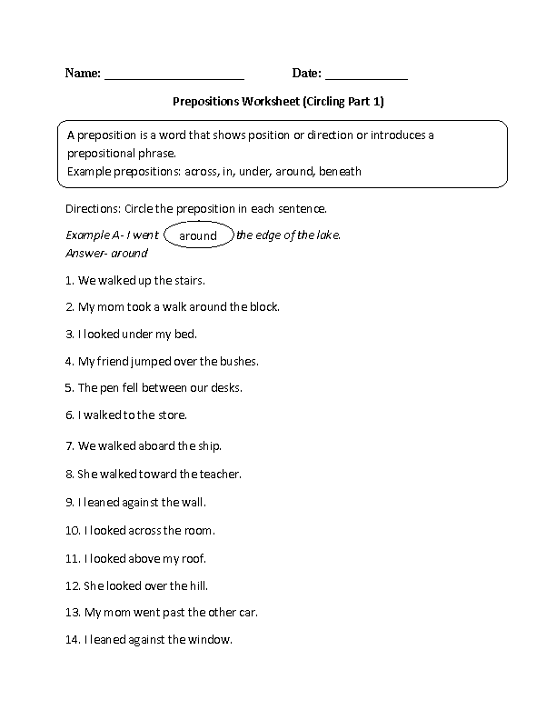
Answer Bank
Between
Across
Around
Under
To
Up
Over
Against
Past
Abroad
Against
Toward
Above

